**DAILY ONLINE ACTIVITIES SUMMARY**

|  |  |  |  |  |  |  |  |  |
| --- | --- | --- | --- | --- | --- | --- | --- | --- |
| **Date:** | **3-6-2020** | | | | | **Name:** | **Pavana P** | |
| **Sem & Sec** | **6A** | | | | | **USN:** | **4AL17CS057** | |
| **Online Test Summary** | | | | | | | | |
| **Subject** | | **PAP** | | | | | | |
| **Max. Marks** | | **20** | | **Score** | | | **16** | |
| **Certification Course Summary** | | | | | | | | |
| **Course** | **Introduction to cloud** | | | | | | | |
| **Certificate Provider** | | | Cognitive classes | | **Duration** | | | 7 hours |
| **Coding Challenges** | | | | | | | | |
| **Problem Statement:**  1.Take a list of length 3 containing integers, find out which is larger, first or last one and set all the elements in the list to be that value. Print the updated list 2. Write a python program to generate prime number in an interval  3. Write a Java Program to Implement Circular Doubly Linked List | | | | | | | | |
| **Status: Completed** | | | | | | | | |
| **Uploaded the report in Github** | | | | | **YES** | | | |
| **If yes Repository name** | | | | | **DAILY STATUS** | | | |
| **Uploaded the report in slack** | | | | | **YES** | | | |

.

**Online Test :**

Subject:-PAP

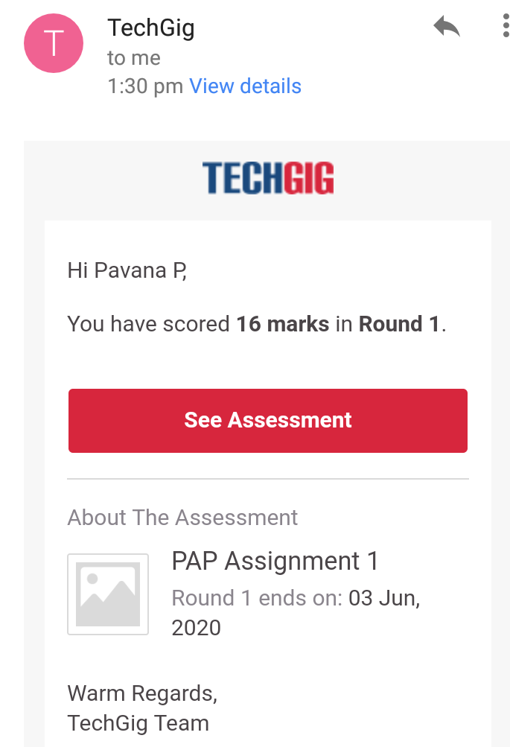

**Certification Course Details:**

**Introduction to cloud :**

Today I have completed these topics:

1.Components of cloud computing.

2.Cloud Computing storage.

3.Content Delivery Network.

4.Emergent Trends.

.

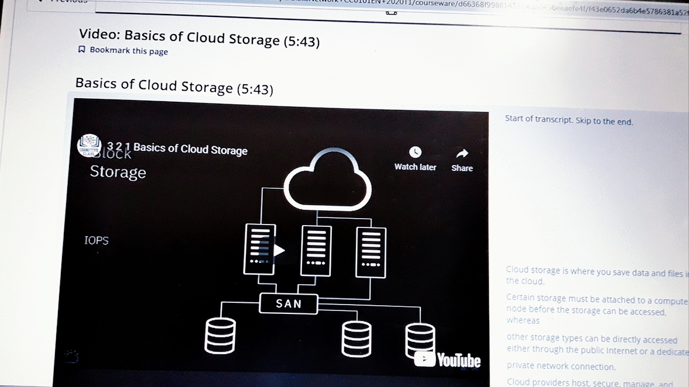

**Coding Challenges Details:**

**https://github.com/pavana-p-kulal/DAILY-STATUS/tree/master/3-6-20/Online%20Coding**